**Year 7 Science Inquiry Skills**

**Cooking Different Lengths of Spaghetti**

**Aim**: To investigate the effect of spaghetti length on the time it takes to cook.

**Equipment**:

* 500mL beaker
* 200mL water
* Thermometer
* Tripod
* Gauze mat
* Retort stand
* Boss head
* Clamp
* Heatproof mat
* Stopwatch
* Safety glasses
* Matches
* Bung
* Paper towel
* Spaghetti
* Tongs

**Method**:

1. Collect equipment and set up as per the diagram below.

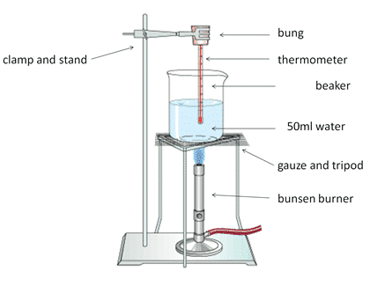

500mL beaker

200mL water

1. Measure and cut five different lengths of spaghetti. Record the lengths in the results table below.
2. Safely light the Bunsen burner and open the air holes to provide the blue flame.
3. Heat the water until it starts to boil. At this point, place the first piece of spaghetti into the water.
4. Time how long it takes for the spaghetti to soften and fall to the bottom of the beaker. Record this in the results table.
5. Turn the air holes of the Bunsen to safety flame, and with tongs, carefully remove the piece of spaghetti.
6. Return to the air holes to blue flame, repeating steps 4 to 6 for the next four pieces of spaghetti.

Results:

|  |  |
| --- | --- |
| Length of Spaghetti (cm) | Time (minutes) |
|  |  |
|  |  |
|  |  |
|  |  |
|  |  |

**Questions**:

1. For this experiment, what was the:
   1. Independent variable?
   2. Dependent variable?
   3. Control variables?
2. Draw an appropriate graph for your data.

|  |  |  |  |  |  |  |  |  |  |  |  |  |  |  |  |  |
| --- | --- | --- | --- | --- | --- | --- | --- | --- | --- | --- | --- | --- | --- | --- | --- | --- |
|  |  |  |  |  |  |  |  |  |  |  |  |  |  |  |  |  |
|  |  |  |  |  |  |  |  |  |  |  |  |  |  |  |  |  |
|  |  |  |  |  |  |  |  |  |  |  |  |  |  |  |  |  |
|  |  |  |  |  |  |  |  |  |  |  |  |  |  |  |  |  |
|  |  |  |  |  |  |  |  |  |  |  |  |  |  |  |  |  |
|  |  |  |  |  |  |  |  |  |  |  |  |  |  |  |  |  |
|  |  |  |  |  |  |  |  |  |  |  |  |  |  |  |  |  |
|  |  |  |  |  |  |  |  |  |  |  |  |  |  |  |  |  |
|  |  |  |  |  |  |  |  |  |  |  |  |  |  |  |  |  |
|  |  |  |  |  |  |  |  |  |  |  |  |  |  |  |  |  |
|  |  |  |  |  |  |  |  |  |  |  |  |  |  |  |  |  |
|  |  |  |  |  |  |  |  |  |  |  |  |  |  |  |  |  |
|  |  |  |  |  |  |  |  |  |  |  |  |  |  |  |  |  |
|  |  |  |  |  |  |  |  |  |  |  |  |  |  |  |  |  |
|  |  |  |  |  |  |  |  |  |  |  |  |  |  |  |  |  |

1. What type of data have you collected (quantitative/qualitative)? How do you know?
2. Make an inference about the observation obtained from this experiment.
3. If you were to repeat this experiment, what improvement would you make to make the results more accurate/reliable?